**Page 1 (m-Way Search Trees)**

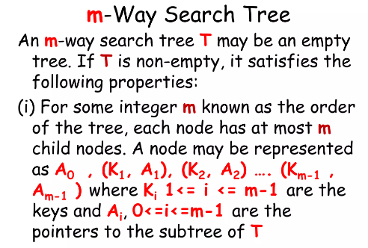

**Page 2 (m-Way Search Trees)**

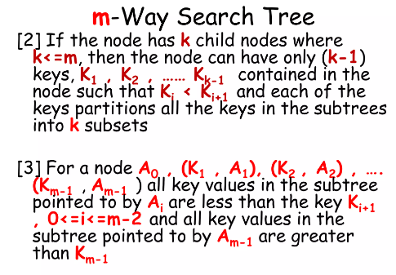

**Page 3 (m-Way Search Trees)**

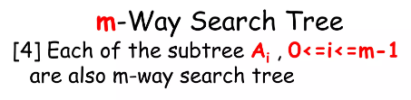

**Page 4 (m-Way Search Trees)**

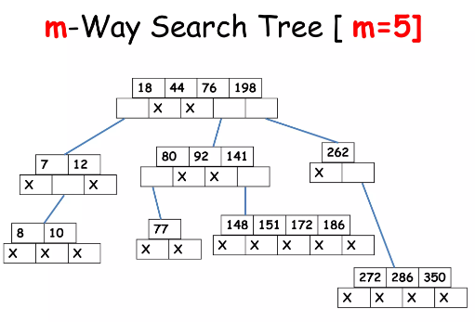

**Page 5 (m-Way Search Trees)**

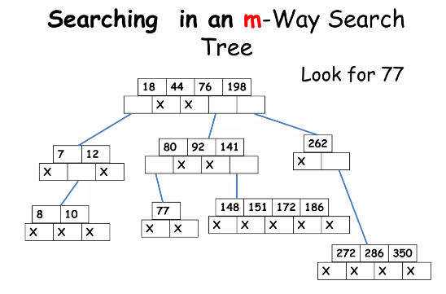

**Page 6 (m-Way Search Trees)**

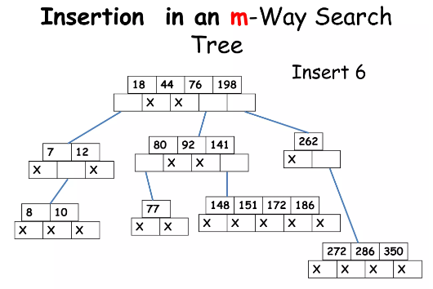

**Page 7 (m-Way Search Trees)**

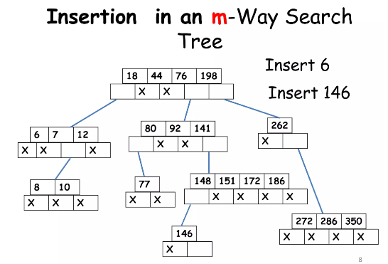

**Page 8 (m-Way Search Trees)  
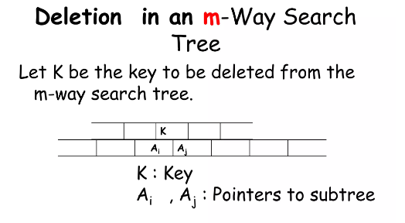**

**Page 9 (m-Way Search Trees)**

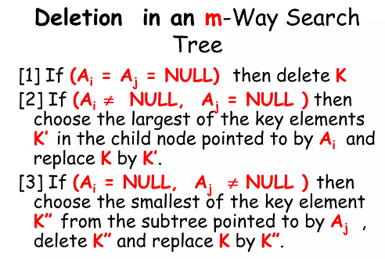

**Page 10 (m-Way Search Trees)**

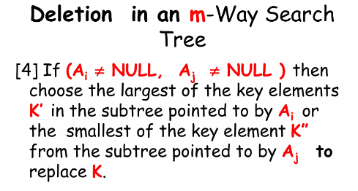

**Page 11 (m-Way Search Trees)**

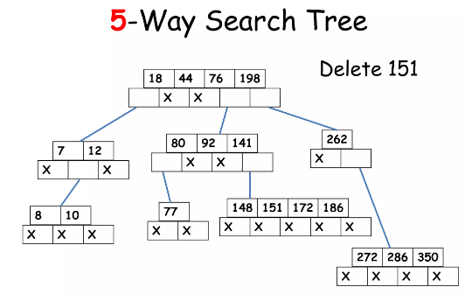

**Page 12 (m-Way Search Trees)**

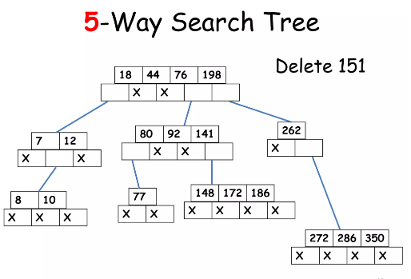

**Page 13 (m-Way Search Trees)**

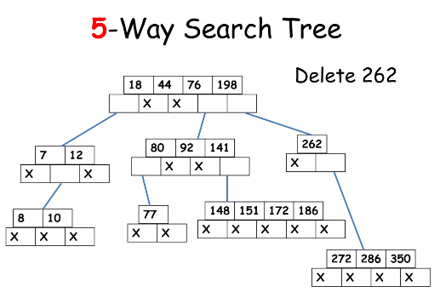

**Page 14 (m-Way Search Trees)**

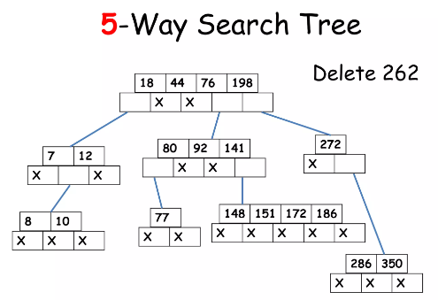

**Page 15 (m-Way Search Trees)**

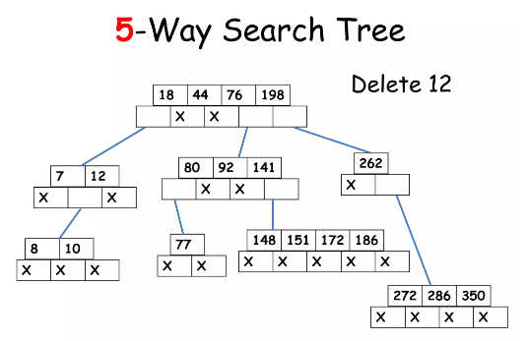

**Page 16 (m-Way Search Trees)**

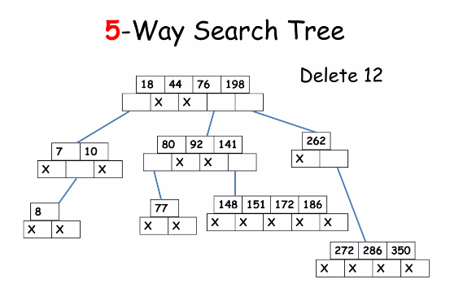

**Page 1 (B-Trees)**

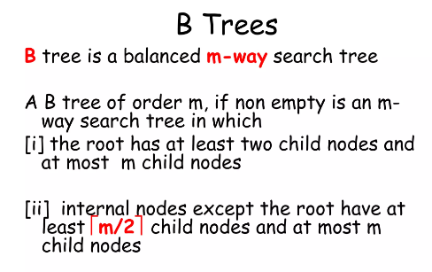

**Page 2 (B-Trees)**

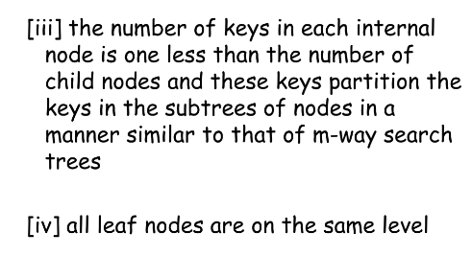

**Page 3 (B-Trees)**

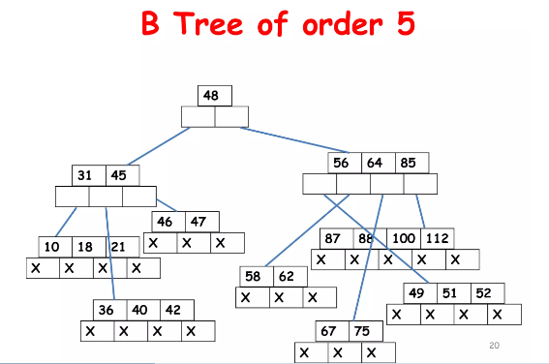

**Page 4 (B-Trees)**

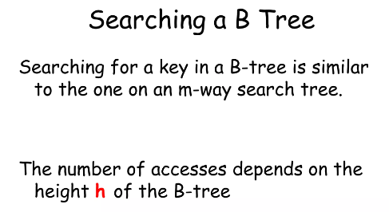

**Page 5 (B-Trees)**

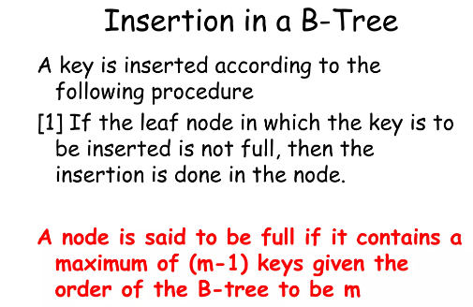

**Page 6 (B-Trees)**

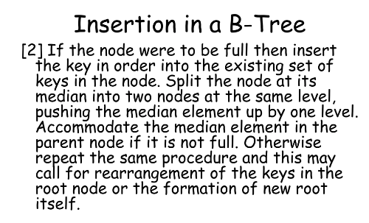

**Page 7 (B-Trees)**

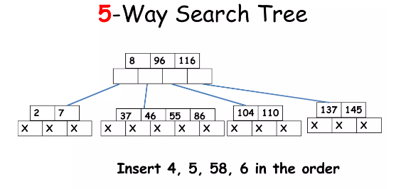

**Page 8 (B-Trees)**

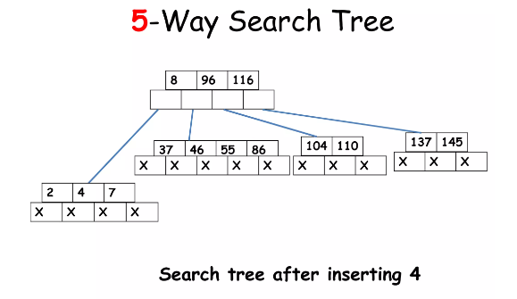

**Page 9 (B-Trees)**

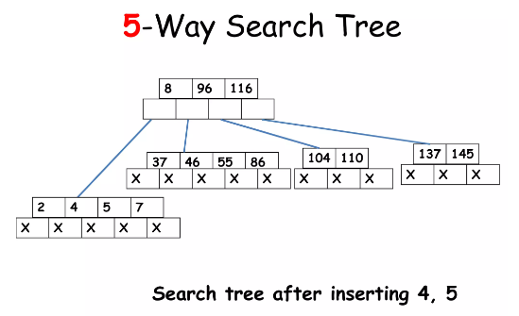

**Page 10 (B-Trees)**

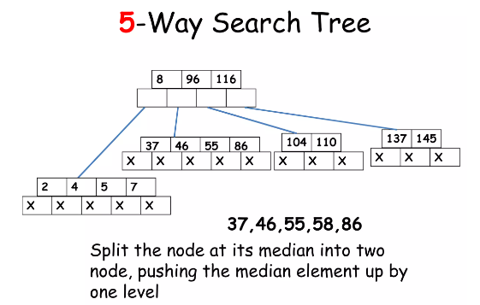

**Page 11 (B-Trees)**

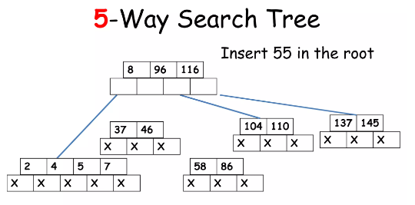

**Page 12 (B-Trees)**

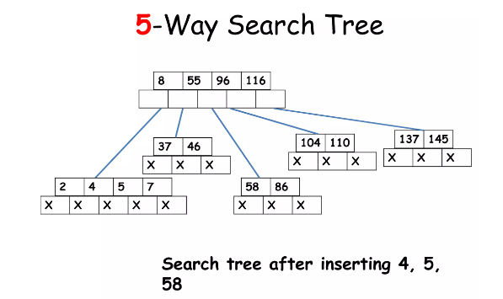

**Page 13 (B-Trees)**

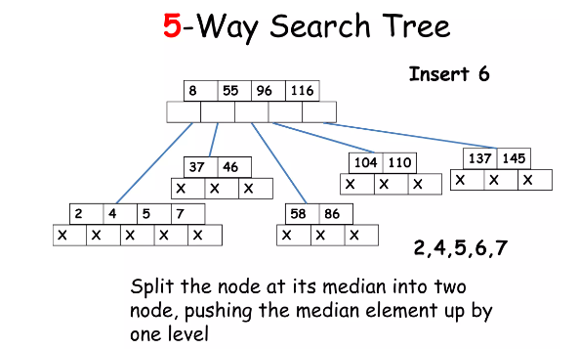

**Page 14 (B-Trees)**

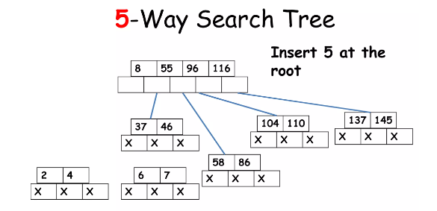

**Page 15 (B-Trees)**

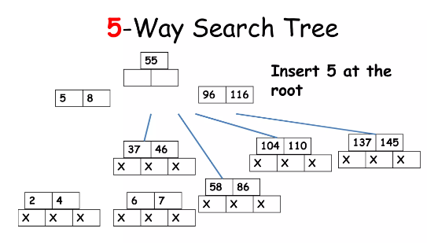

**Page 16 (B-Trees)**

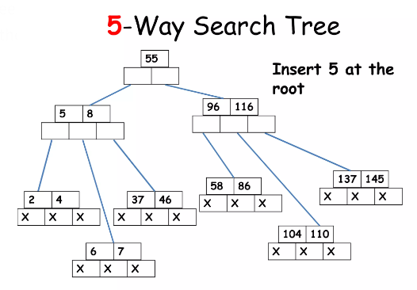

**Page 17 (B-Trees)**

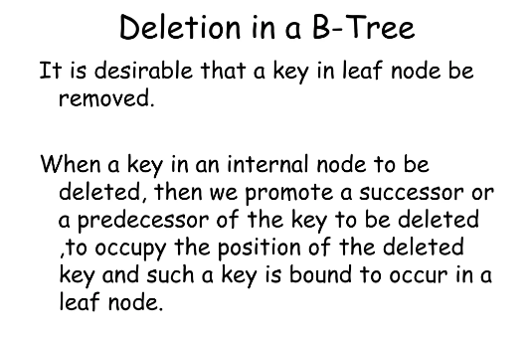

**Page 18 (B-Trees)**

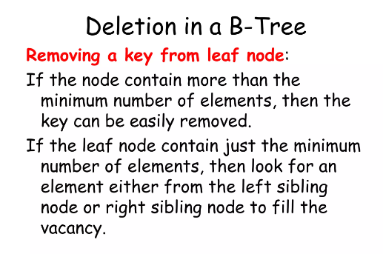

**Page 19 (B-Trees)**

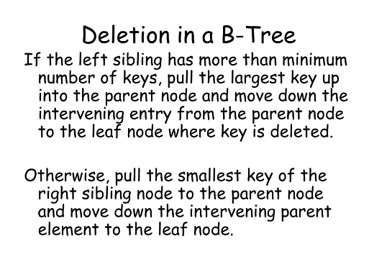

**Page 20 (B-Trees)**

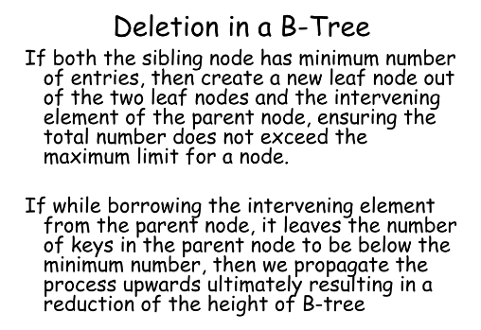

**Page 21 (B-Trees)**

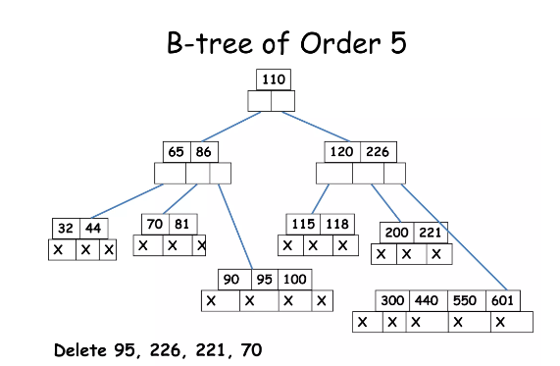

**Page 22 (B-Trees)**

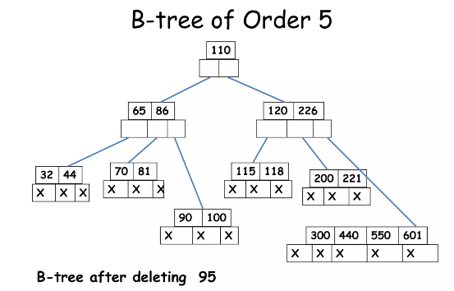

**Page 23 (B-Trees)**

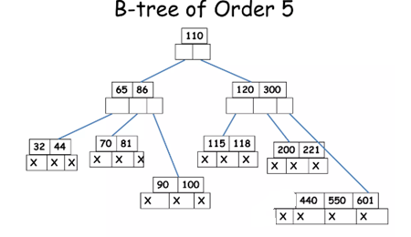

**Page 24 (B-Trees)**

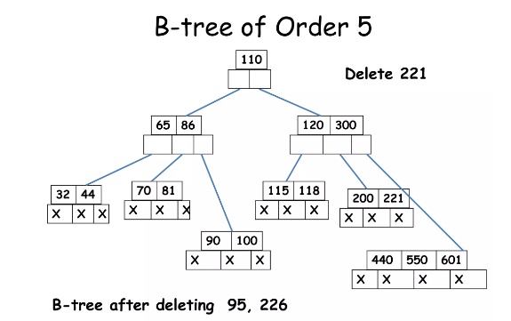

**Page 25 (B-Trees)**

